PROJECT REPORT

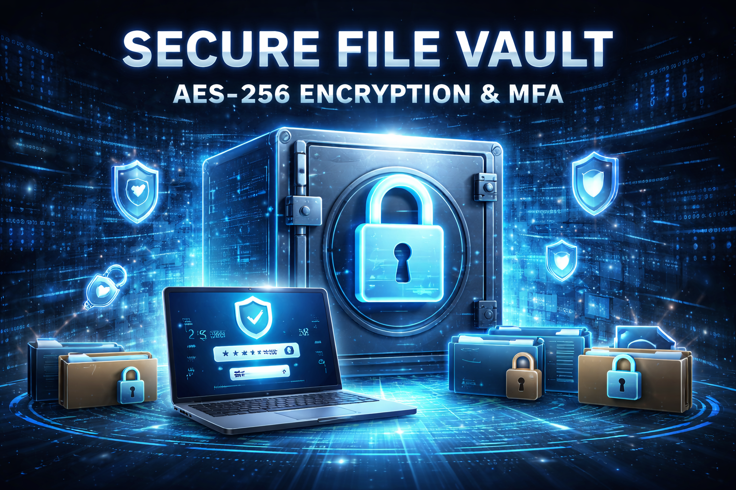

Project Title:
Secure File Vault Using AES-256 Encryption
And
Multi-Factor Authentication (MFA)

Course: Information Security

Group Members:
Abdulrehman (BSE233133)
Syed Zain-Ul-Abideen (BSE233196)
Waleed Zohaib (BSE233144)

REPORT

1. Introduction
In today’s digital era, data security has become a major concern for individuals and organizations. Sensitive files such as personal documents, academic records, business data, and credentials are often stored digitally. Without proper protection mechanisms, these files are vulnerable to unauthorized access, data breaches, and cyberattacks. This project proposes the development of a Secure File Vault system that ensures strong protection of files using advanced cryptographic techniques and multi-factor authentication.
The Secure File Vault will be developed on Kali Linux, a security-focused operating system widely used in cybersecurity. The system will encrypt files using AES-256 encryption, which is a globally trusted encryption standard, and will require users to authenticate using multiple factors before accessing or decrypting any file.

2. Problem Statement
Many existing file storage solutions rely on weak security measures such as simple passwords or operating system-level permissions. These approaches are insufficient against modern cyber threats like brute-force attacks, credential theft, and insider misuse. If an attacker gains access to the system, sensitive files can be easily compromised.
Therefore, there is a need for a secure file storage mechanism that combines strong encryption with robust authentication. The proposed Secure File Vault aims to address these challenges by encrypting files and enforcing multi-factor authentication to ensure only authorized users can access protected data.

3. Objectives of the Project
The primary objectives of this project are:
- To design and implement a secure file vault on Kali Linux
- To encrypt files using AES-256 encryption to ensure confidentiality
- To implement secure password-based authentication
- To integrate Multi-Factor Authentication (Password + One-Time Password)
- To securely manage encryption keys and authentication data
- To provide a user-friendly command-line interface
- To demonstrate practical implementation of Information Security concepts

4. Scope of the Project
The scope of this project is limited to a local secure file storage system. The system will support encryption and decryption of files stored on the same machine. It will be designed for a single user and will operate through a command-line interface.
The project does not include cloud storage, mobile access, or graphical user interfaces. However, the system architecture will be designed in a way that allows future extensions.

5. Proposed System Overview
The Secure File Vault system will operate in a structured and secure manner. Initially, the user will register by setting a strong password. The password will never be stored in plain text; instead, it will be securely hashed using bcrypt.
For multi-factor authentication, the system will generate a unique OTP secret for the user. This secret will be used to generate time-based one-time passwords through an authenticator application. During login, the user must provide both the correct password and a valid OTP.
After successful authentication, the user will be able to encrypt files and store them in a secure vault directory. Decryption will only be possible after re-authentication, ensuring strict access control.

6. Tools and Technologies
The following tools and technologies will be used in this project:
- Operating System: Kali Linux
- Programming Language: Python 3
- Encryption Algorithm: AES-256
- Cryptographic Library: cryptography
- Password Hashing: bcrypt
- Multi-Factor Authentication: pyotp
- Interface: Command Line Interface (CLI)
- Logging: Text-based activity logs

7. Methodology and Development Steps
The development of the Secure File Vault will follow a phased and structured approach:
Phase 1 – Environment Setup:
The Kali Linux system will be updated, and required Python libraries will be installed. A virtual environment will be created, and the project directory structure will be organized.
Phase 2 – Project Structure Design:
The project will be divided into multiple modules such as authentication, encryption, key management, and file operations to ensure clean and maintainable code.
Phase 3 – Cryptographic Key Management:
A secure 256-bit encryption key will be generated. The system will handle key storage and retrieval securely.
Phase 4 – AES-256 Encryption Implementation:
Files will be encrypted using AES-256 with secure modes of operation and proper initialization vectors.
Phase 5 – Authentication System:
Password registration and verification will be implemented using bcrypt hashing.
Phase 6 – Multi-Factor Authentication:
OTP-based authentication will be added using time-based one-time passwords.
Phase 7 – File Vault Operations:
Logic for encrypting, storing, and decrypting files will be implemented.
Phase 8 – User Interface:
A simple and user-friendly CLI menu will be created.
Phase 9 – Logging and Monitoring:
User actions such as login attempts and file operations will be logged.
Phase 10 – Testing and Validation:
The system will be tested for correctness, security, and error handling.

8. Security Features
The Secure File Vault incorporates multiple security features including AES-256 encryption, secure password hashing, multi-factor authentication, protected key management, and access-controlled file storage.

9. Limitations
The system is limited to command-line usage, supports a single user, and stores data locally. Advanced features such as cloud integration and multi-user access are not included.

10. Future Enhancements
Future improvements may include a graphical user interface, support for multiple users, role-based access control, cloud-based encrypted storage, and hardware security integration.

11. Conclusion
This project provides a comprehensive implementation of core Information Security principles. By combining strong encryption with multi-factor authentication, the Secure File Vault ensures high levels of data confidentiality and access control. The project serves as a strong academic and practical demonstration of secure system design.
Proposed By: Abdulrehman Azeem, Syed Zain-Ul-Abideen, Waleed Zohaib
Course: Information Security
Platform: Kali Linux

